38.27: a) 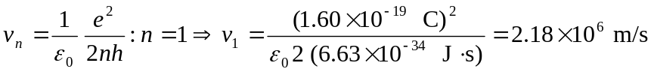
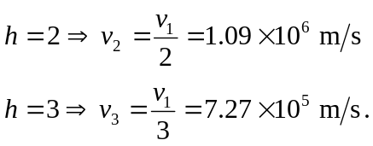

b) Orbital period 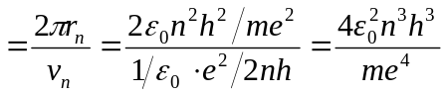
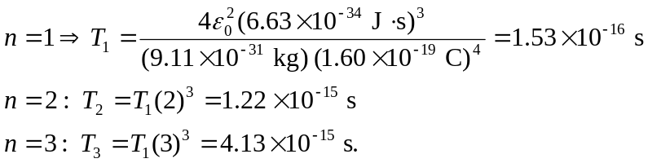
c) number of orbits 